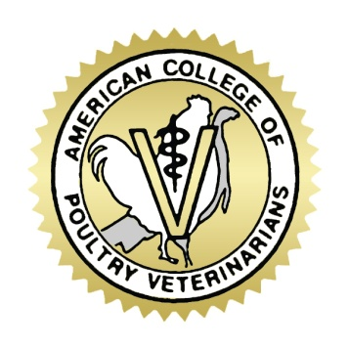
American College of Poultry Veterinarians
Board of Governors Meeting
Monday, February 29, 2016
10:00 am to 11:00 am
Conference Call
Call in Number: 904-513-2695
Participant Code: 94791152

1. Welcome Becky Tilley

2. Approval of July Board Meeting Minutes Becky Tilley

3. Budget Year to Date Bob Bevans-Kerr

4. ABVS Response to the 2015 ACPV 5 Year Report Karen Grogan

5. Emeritus Member Applications Janece Bevans-Kerr

6. Electronic Delivery of the Exam Bob Bevans-Kerr

7. Updates
Withdrawn Member Janece Bevans-Kerr
Applicant Appeal Janece Bevans-Kerr
2016 ACPV Workshop Bob Bevans-Kerr
2017 ACPV Workshop Bob Bevans-Kerr
Dues and CE Submissions Janece Bevans-Kerr

